Charlie Say

OSUID: 934377368

CS 372 - Intro Networks

Project 3

Instructions on running program:

- Download the python files into a directory

- Open terminal

- Navigate to directory where python files are located

- Open a terminal

- Run this file first: chatserver.py (python3)

- Open a new terminal

- Run this file second: chatclient.py (python3)

CLIENT SIDE CHAT TERMINAL

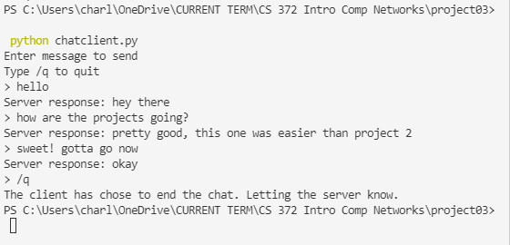

SERVER SIDE CHAT TERMINAL

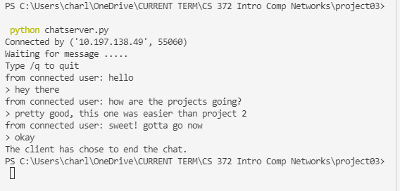

####################### EXTRA CREDIT #######################

Instructions on running program:

- Download the python files into a directory

- Open terminal

- Navigate to directory where python files are located

- Open a terminal

- Run this file first: chatserver.py (python3)

- Open a new terminal

- Run this file second: chatclient.py (python3)

- In chatclient.py: type in “play” and press enter

In this program, the client will choose a word for the server (player) to guess. The program will open a new server (hangmanserver.py) and a new client (hangmanclient.py).

HANGMAN SERVER

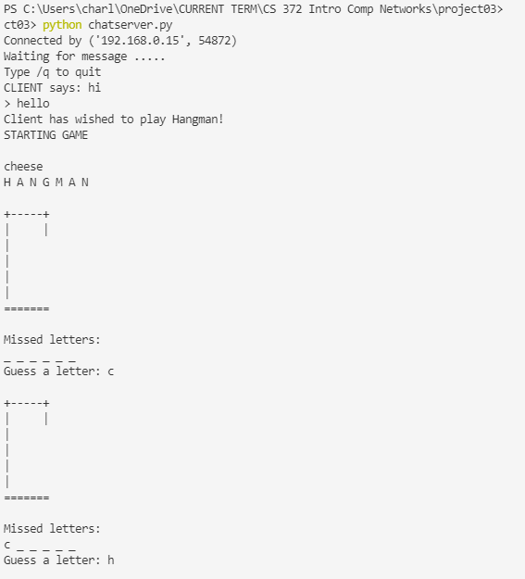

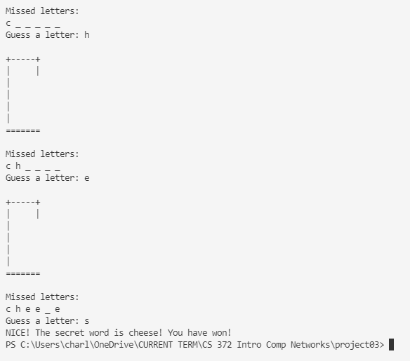

HANGMAN CLIENT

